Inclusion Ireland Financial Statements

Our auditors have checked our accounts for 2023 and the full Financial Statements for Inclusion Ireland is available on our website www.inclusionireland.ie

At the end of 2023, there was 11 people on the Board of Directors.
Inclusion Ireland has an inclusive Board. 4 members of the board have lived experience of intellectual disability. There is a support worker to assist the 4 directors.

Inclusion Ireland Board of Directors 2023
Directors Name | Notes
David Fraughan
Maria Panza | Resigned on 31St August 2023
Tomás Murphy
Martin Rowan
Ashley Sands
Briana Fitzsimons | Appointed on 9th August 2023
Marian McNamara
Marianne Garvey-McMahon | Resigned on 10th August 2023
John Moore
Rona Bowe | Appointed on 4th October 2023
Siobhan Bryan
Nora Torpey | Resigned on 31St August 2023
Sara Jane Lavin
Glenn Shanley
Inclusion Ireland Directors 1

Directors’ Report:
• The Board approved the Financial Statements on 8 June 2024
• The Audit, Risk and Quality Committee proposes the annual budget to the Board and reviews the company’s activities and costs during 2023 and provides a regular report to the Board.
• All Board Directors are volunteers and receive no pay or benefit from their position.
• The Directors are satisfied that the company finances are healthy.
• The Directors continue to carry out the processes and reporting required by the Charity Regulator and Charities Act 2009 and Standards in Public Office Act 2001

Compliance with Sector-Wide Legislation and Standards
The charity engages pro-actively with legislation, standards and code which are developed for the sector. Inclusion Ireland subscribe to and is compliant with the Companies Act 2014 and The Charity Statement of recommended Practice (SORP - FRS 102).

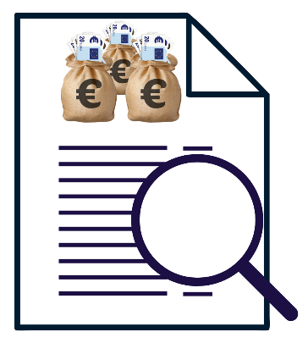
Our auditors have checked our accounts for 2023, and the full Financial Statements for Inclusion Ireland is available on our website www.inclusionireland.ie or by clicking on Accessible Accounts

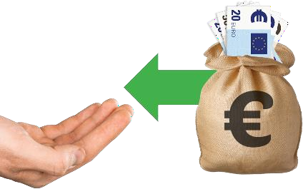
This section takes an overall look at our money. It talks about the money we had come in. This is called our income.

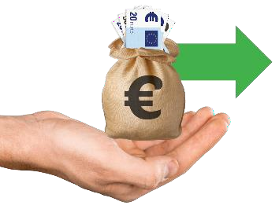
It also looks at the money we spent. This is called our expenditure.

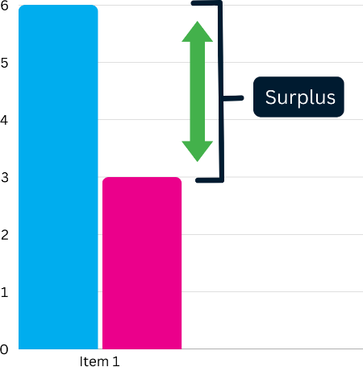
The difference between these amounts is called the surplus. If there is a minus symbol before the number this means we have less money than we had come in. If there is no minus symbol this means that we have more money.

Expenses (money  we spend) | 2023 | 2022
Total | € 1,020,617 | € 960,760

Overall surplus  for 2023 | €-101,326 | €6,080
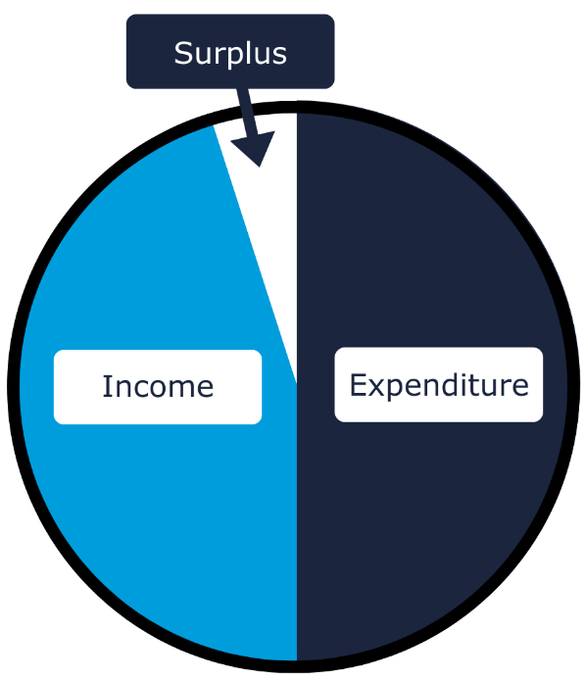

Expenditure | €1,020,617
Income | €919,291
Surplus | -€101,326

Inclusion Ireland 2023 Accounts Explained

We have funding that comes from different places including:

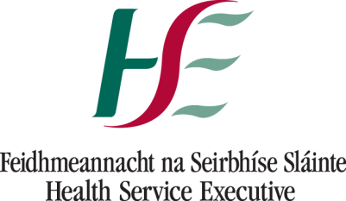
- The HSE is our main funder and our funding for 2023.

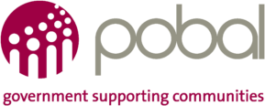
- Pobal under the Scheme for Supporting National Organisations (SSNO).

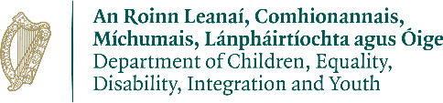
- Department Children, Equality Disability Integration and Youth (DCEDIY) for organising the Disability Participation and Consultation Network (DPCN).

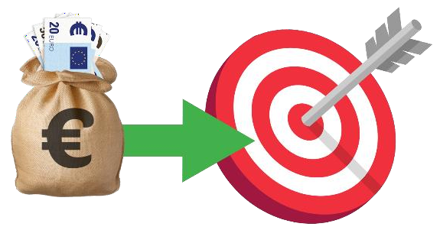
We also get some smaller grants for other projects. Inclusion Ireland is always looking at other sources of income to meet our strategic goals.

Breakdown of Income of the €919,291 we got:
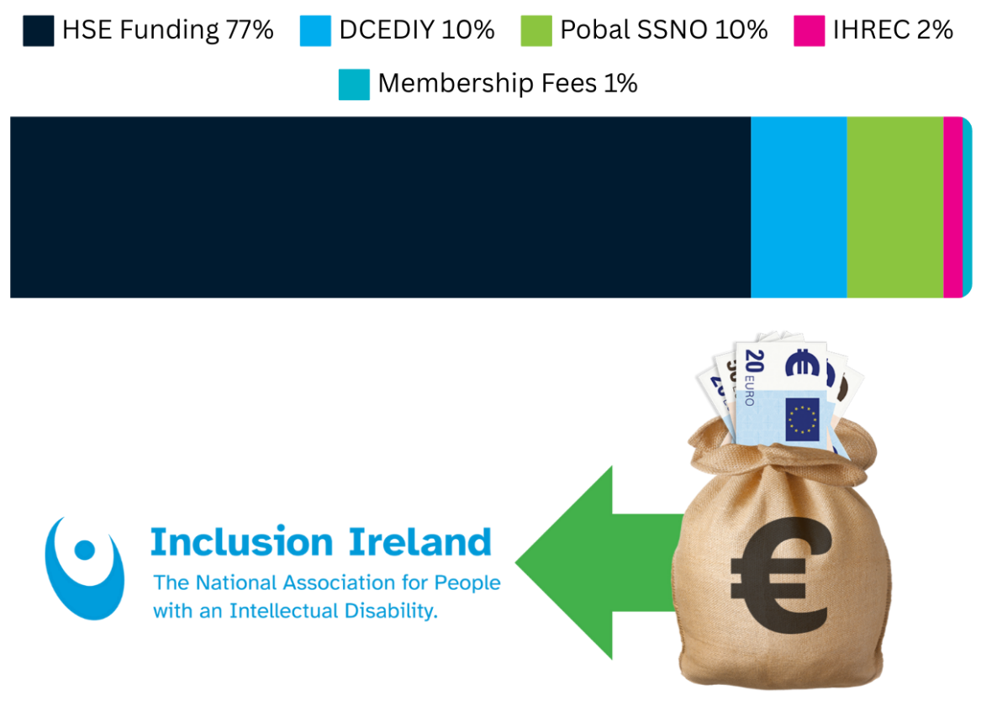

- The biggest amount of funding came from the HSE. This was 77% of our funding.

- The Department of Children, Equality, Disability, Integration and Youth (DCEDIY) and Pobal both gave 10% of our funding.

- The Irish Human Rights and Equality Commission gave us 2% of our funding.

What we spent our €1,020,617 on:
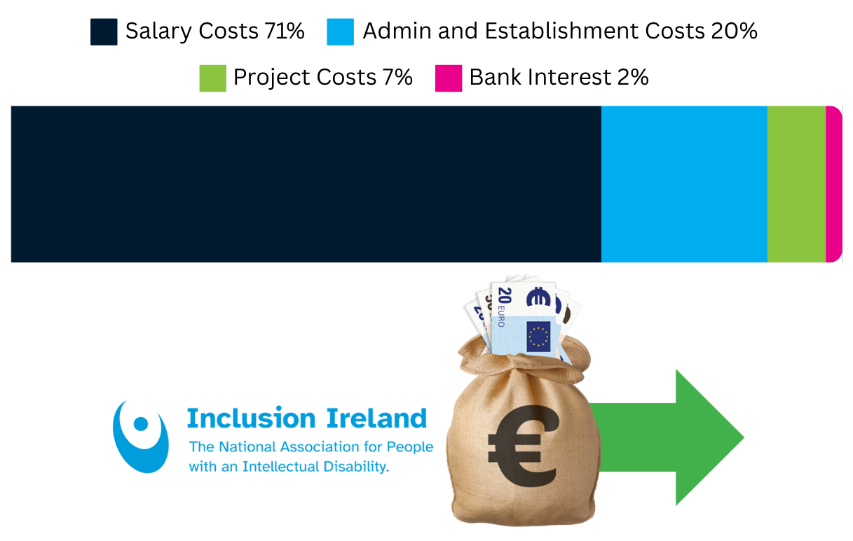

- Our biggest spend was on salary costs or staff wages.

- We spent 20% of our money on administration and establishment costs. This is money we spend on running our offices including utility bills, expenses, office supplies, legal fees etc.

- We spent 7% on project costs. These projects included: SSNO, IHREC, CYPSC, DCEDIY and costs for self-advocacy.

- Our bank interest cost us 2% of our money.

Inclusion Ireland Balance Sheet Summary
As of December 31st, 2023

Money we have | Euro (€)
Fixed assets (building) | 432,400
Fixed assets (computers, desks, etc.) | 1,619
Current assets (money in the bank) | 263,592
Current assets (debtors) | 31,185
Total | € 728,796
Money we have 1

Money we owe | Euro (€)
Mortgage account | 335,908
Other bills that are not yet paid | 92,323
Total | € 428,231
Money we owe 1

Overall assets | € 300,565

