
What is a self advocacy group?

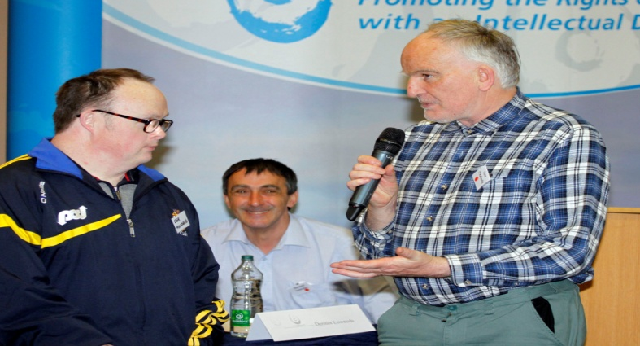  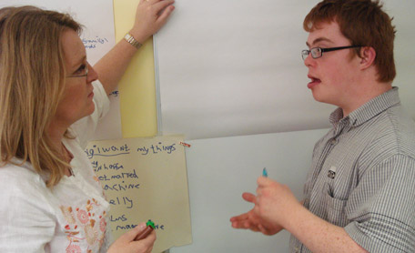     | An advocacy group is a rights group.  An advocacy group is for people who want to learn more about their rights and to speak up for themselves.  A rights group is for people who want to be involved in how decisions are made.  An advocacy group is for people who want to work together and support each other and have their voice heard.  An advocacy group is run by the people who are in it – group members.  Members of an advocacy group should have the control and say in how the group is run.
   | Who can join an advocacy group?  A person who likes working in groups.  Someone who enjoys going to meetings and working hard.  A person who wants to learn more about their rights.  Who can join an advocacy group?  Someone who would like to be more confident in themselves.  Have more of a say in how things are done.

   | What can you learn if you join an advocacy group?  You can learn life skills and learn from listening to other people’s ideas.  You can meet new people.  Having support from your peers and friends can help you be more confident.  You can lean to make your own opinions.  Working together in a group can be safer because there is safety in numbers.  You can have new experiences like meeting managers or other people in charge.
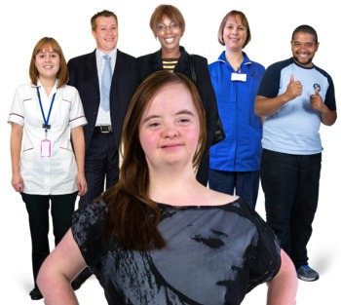 | What can you change by joining an advocacy group?  Your advocacy group can work towards changing services and how things are done.  Being in a group can mean you have a stronger voice and say in how your service is run.  One way to have a say is to get involved in interviewing staff and have planned prepared meetings with management.
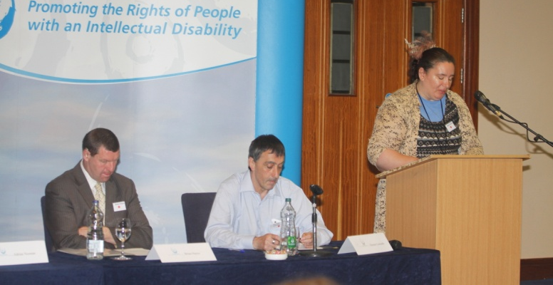 | Your group can teach people about the views and rights of people with disabilities.

