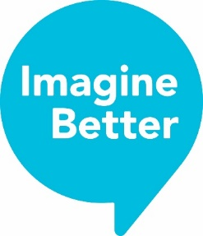


Spaces of Belonging
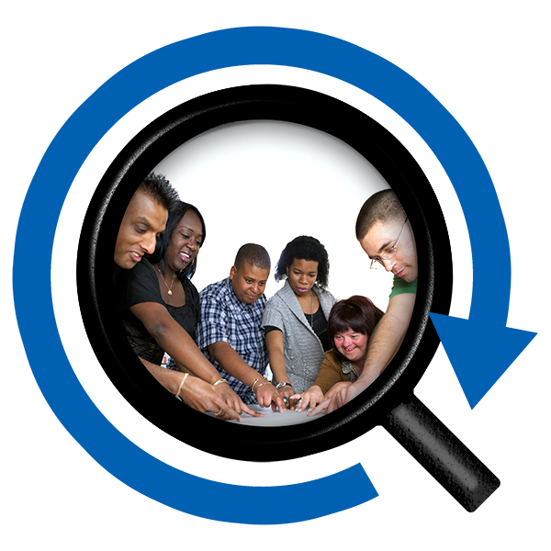
A report about disabled people’s experiences of belonging, place and community

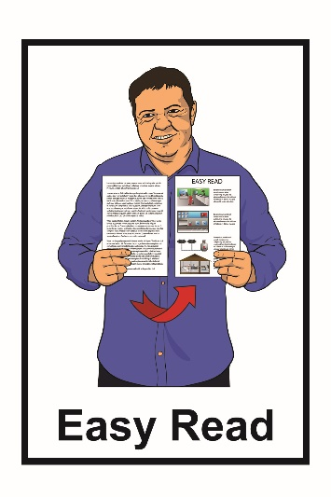
What is in this book?
Page number
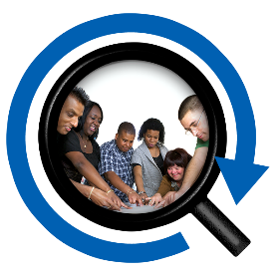

What is Spaces of Belonging? 3
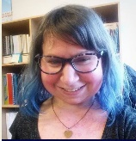
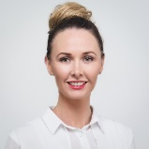
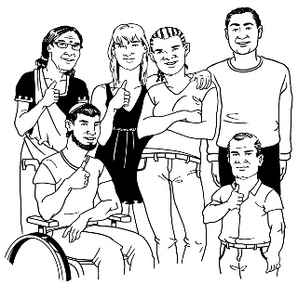
Who did this research? 7

Who the researchers talk to?.. ………..10
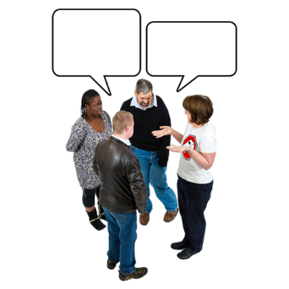

What did people talk about?.........................14

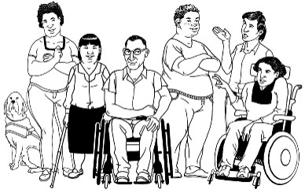
What did people say about
being in places with other
disabled people? 18

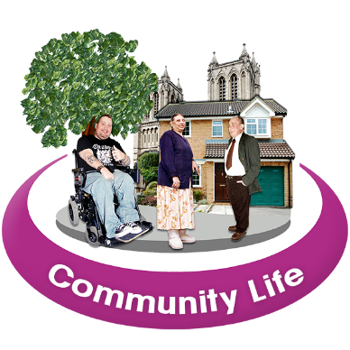
Page number

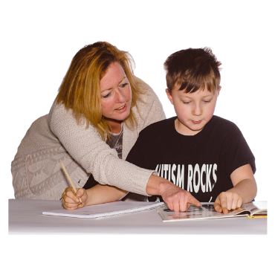
What did people say
about public spaces? 26

What did people say about school? 30


What did people say about work? 34

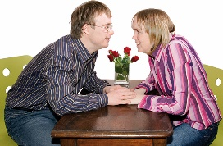
What did people say about
dating and relationships? 36
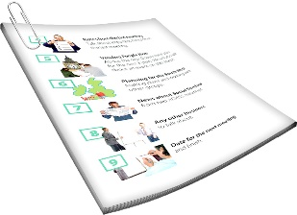

Why is this research important? 41
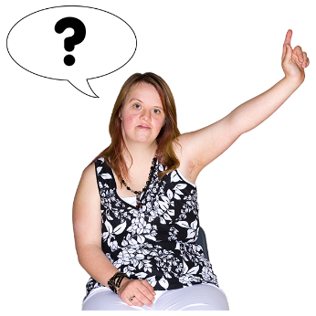

How can I find out more about
this research project? 45

What is Spaces of Belonging?

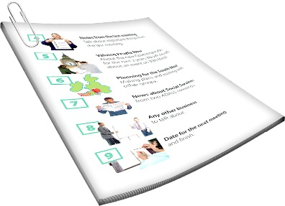
Spaces of Belonging is the name of a research project.

Research means:
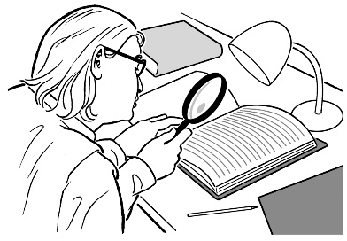
- looking to find an answer to a question you have

- trying to find out how to do things better.

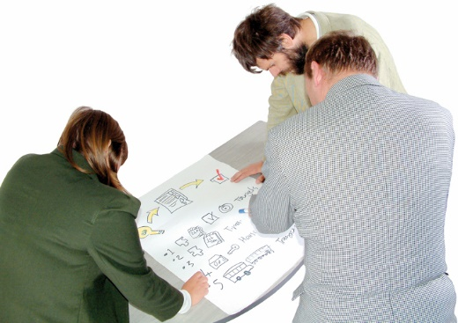
Project means that a group of people want to do something.

They work together to make a plan.

Then they work together to follow the plan to get the work finished.
3 organisations were part of this project.

The organisations were:
- Disabled Persons Assembly
New Zealand
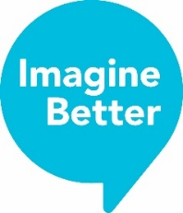

- Imagine Better

- Waikato University.

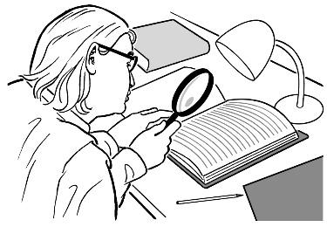
We wanted to find out more about what disabled people and their families:

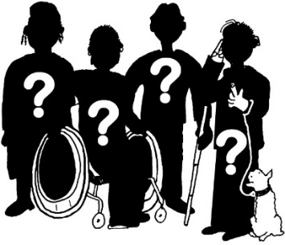
- think about their lives

- feel about their lives.

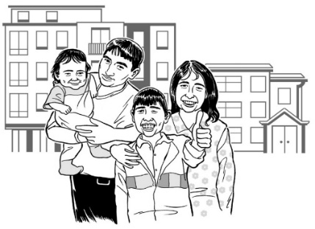
We wanted to find out if disabled people and their families feel like they belong in the places they go.

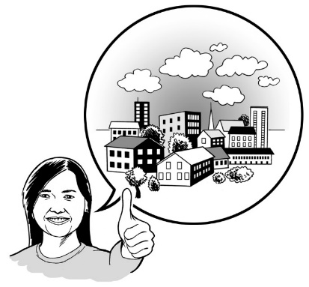
You feel like you belong when you:

- feel welcome
- feel comfortable

- can be yourself.

We also wanted to find out what:

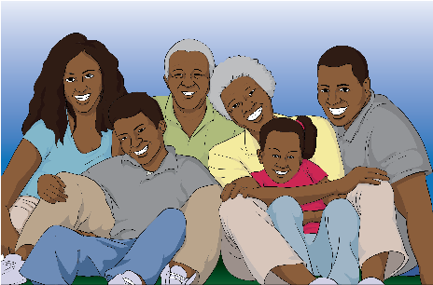
- it is like when people belong

- people feel when they belong

- helps people to feel they belong
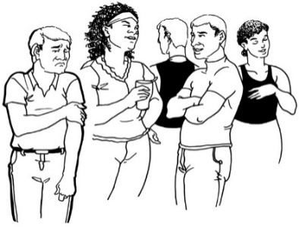

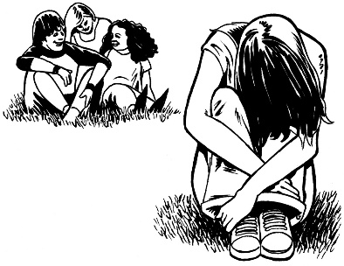
- it is like when people do not feel like they belong
- why people felt like they do not belong somewhere.

Who did this research?

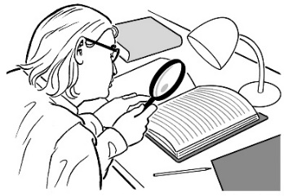
Dr Esther Woodbury and Dr Carey Ann Morrison did the research for our project.

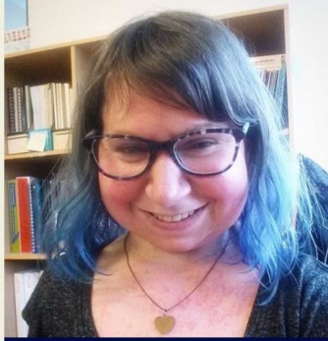
This is Esther.

Esther was working at Disabled Persons Assembly when this research was done.

Disabled Persons Assembly is also called DPA for short.

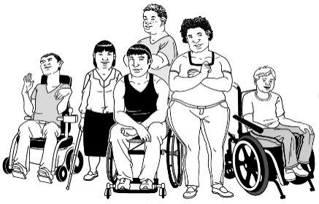
DPA is a Disabled People’s Organisation that is run by and for people with all kinds of disabilities.

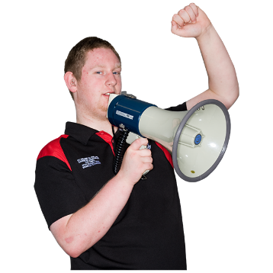
DPA speaks up about a lot of things.
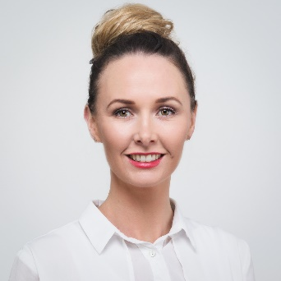
This is Carey Ann.

Carey Ann works at Imagine Better.

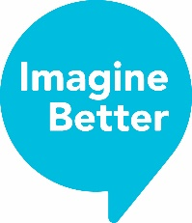
Imagine Better is a group of:

- disabled people

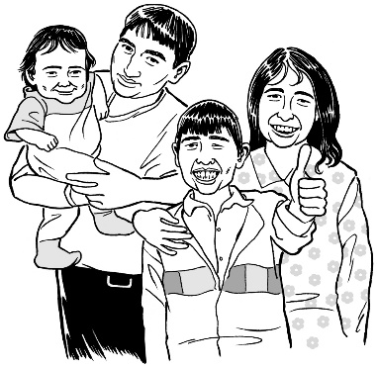
- people who support disabled people like friends or family.

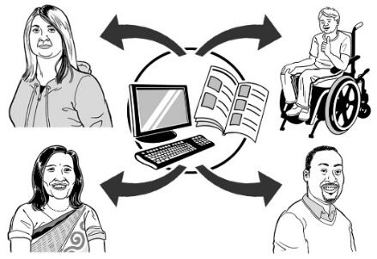
Imagine Better does things like:
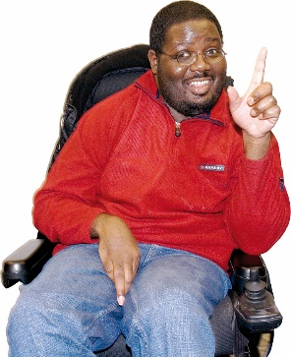
- give information about things that can support disabled people to have good lives

- come up with new ideas to make things better for disabled people.

Lynda and Robyn from Waikato University worked with Esther and Carey Ann on this research.

Who did the researchers talk to?

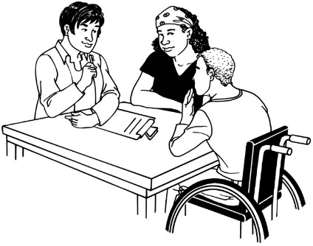
The researchers asked 15 people questions about their lives.

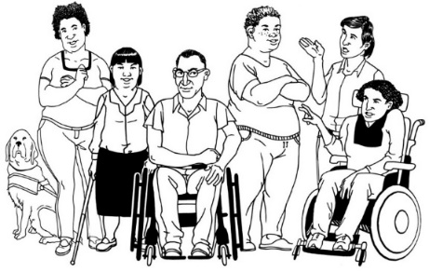
11 people of the 15 people they talked to were disabled.

The people had different disabilities.

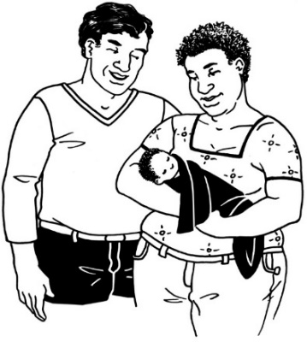

Some people had been disabled since they were born.

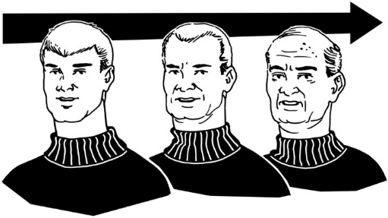
Some people got their disabilities when they were older

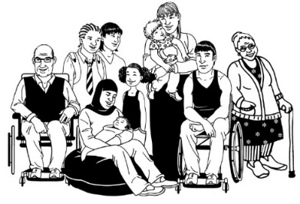
Some people had disabilities you could see.

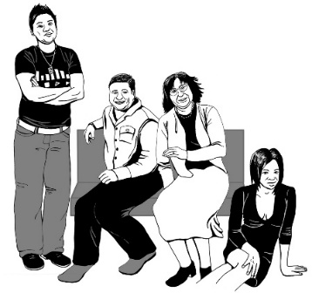

Some people had disabilities you could not see.

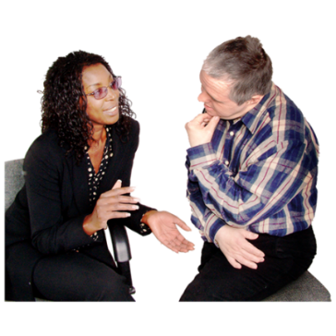

The people talked about what it was like to live with a disability.

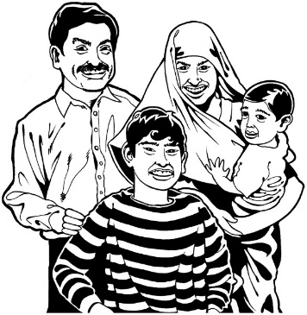
4 people had disabled people in their families.

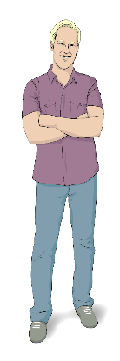

Most of the people they talked to were Pākehā.

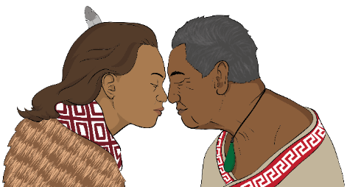

1 person was Māori.

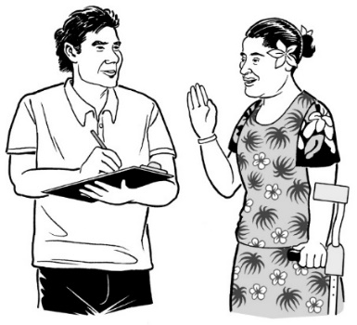

1 person was Pasifika.

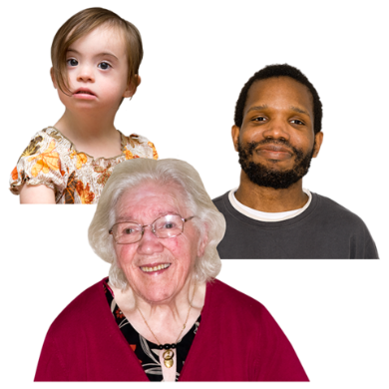
The people they talked to were different ages.

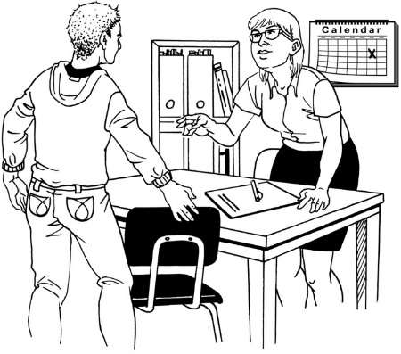

The youngest person was in their 20s.

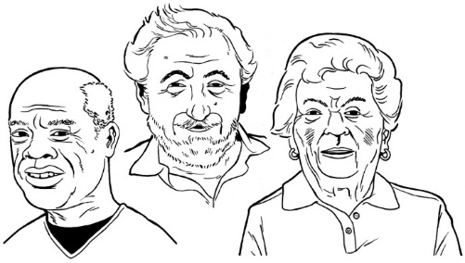
The oldest was more than
65 years old.

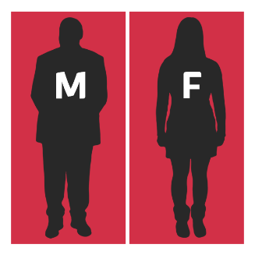
There were:

- 10 women

- 5 men.

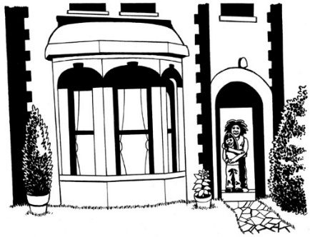
About half of the group of people owned their own home.

What did people talk about?

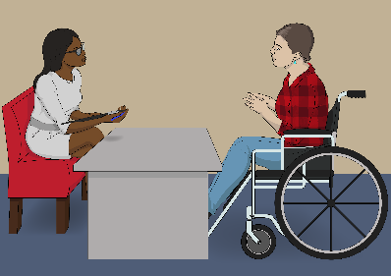
People talked about lots of different things.

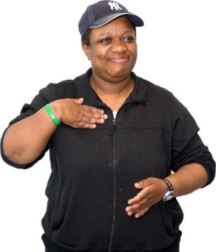

They talked about who they were.

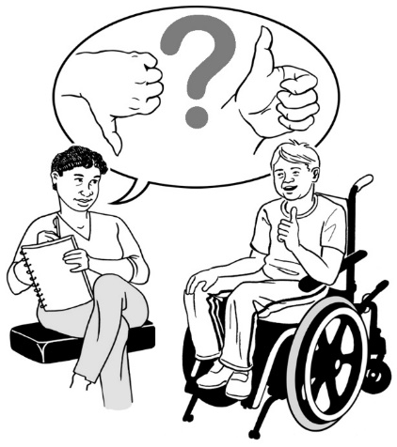
They talked about:

- good things in their lives

- bad things in their lives.

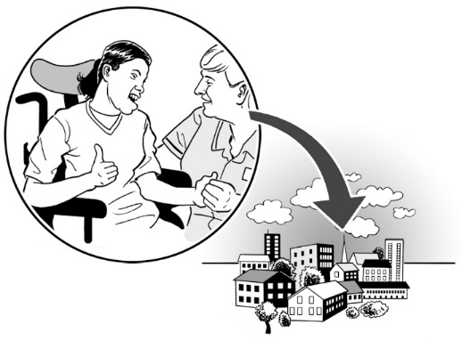
They talked about places they:

- like to go

- stay away from.


Some of the places they talked about were:

- work
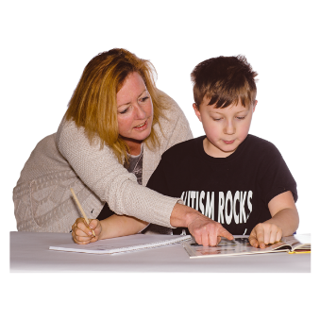
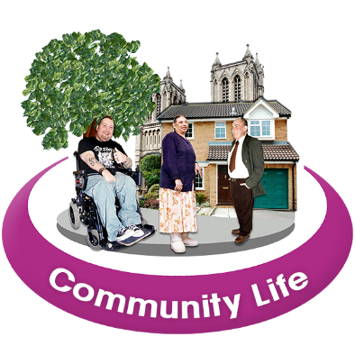
- school

- public spaces.

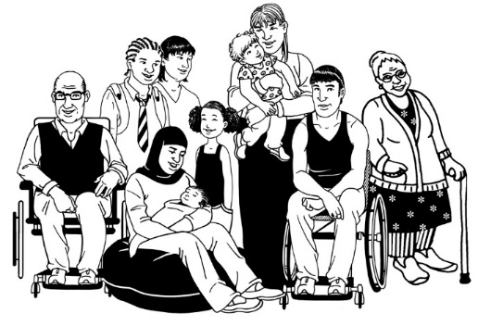

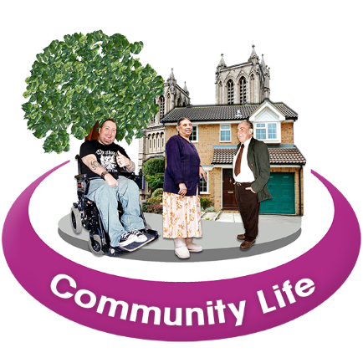
Public places are spaces where everyone is allowed to go.

A public space can be somewhere like a:

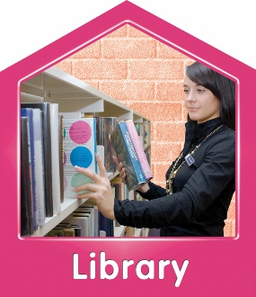
- park
- beach
- library.

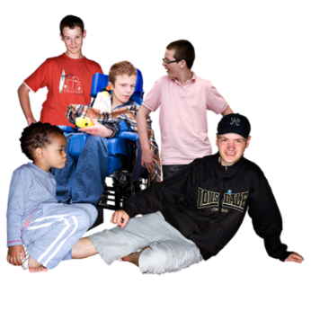
They also talked about:

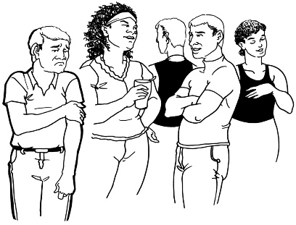
- being in places with other disabled people
- the way that strangers talk to them

- relationships

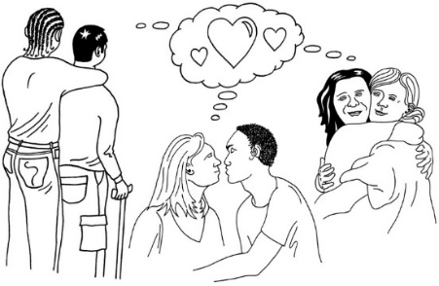
- dating

- sex.

What did people say about being in places with other disabled people?
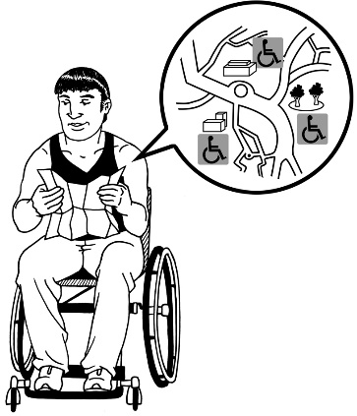

Disabled people go to lots of different places.

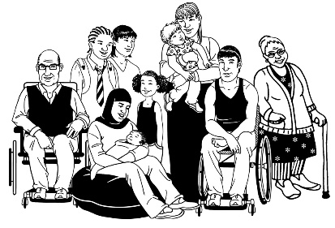
Some of these places are just for disabled people.

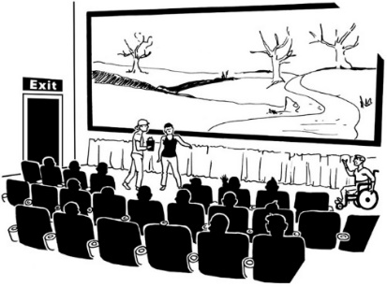
Sometimes disabled people spend time with other disabled people in public places where everyone goes.

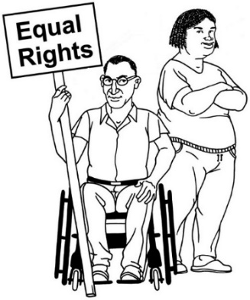

Sometimes disabled people work together to make sure disabled people get their rights.
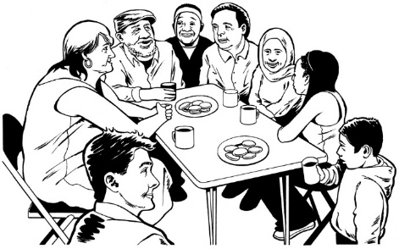
Some people that we talked to go to these places a lot.

Some people do not.



Some of the people we talked to want to go to these places more.

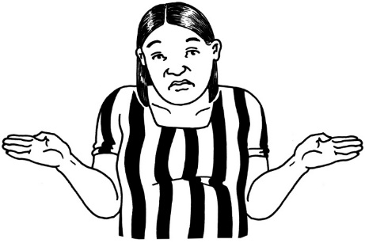
Some people were not sure if they wanted to go to these places more.


Good things about places that are shared with other disabled people:

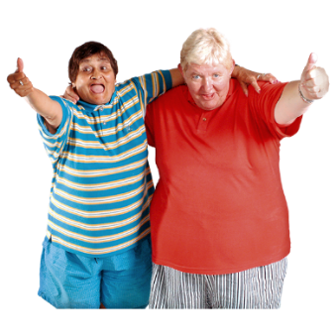
Some of these places are good because:

- the people there understand disability
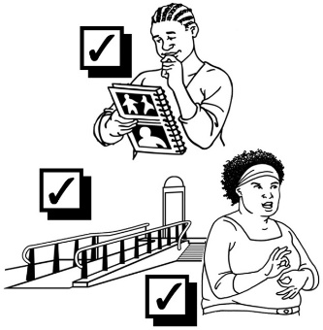
- disabled people can get the things they need to join in

- disabled people can talk about things like:

- how to make life easier
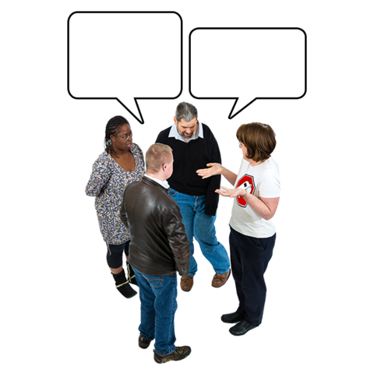
- things that are helpful

- new ideas about disability.
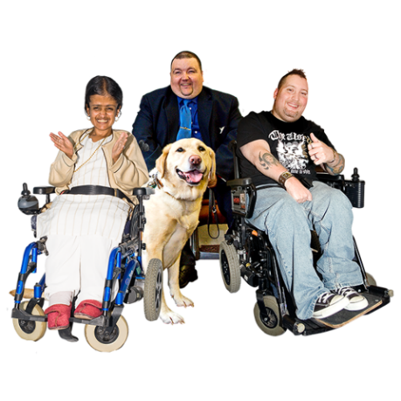
In these places disabled people can talk to each other.

Sometimes people find out that things that have happened to them have also happened to other disabled people.

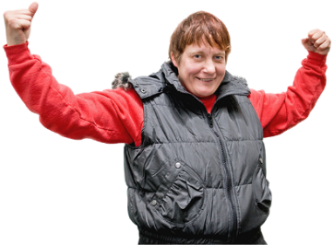
People said they felt safe and strong in places with other disabled people when people try to make them feel welcome.


Not so good things about places that are shared with other disabled people:

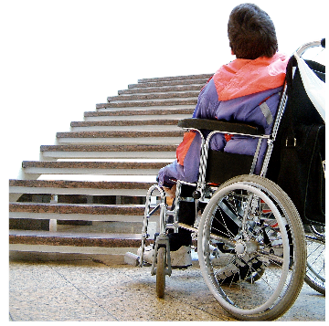
In some of these places disabled people still cannot always get the things they need.

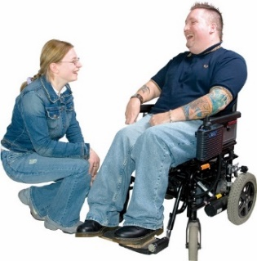
People said this can be okay if people still try their best to make disabled people feel welcome.

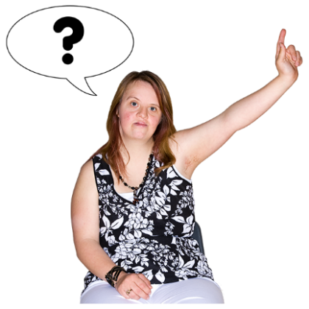

In some of these places disabled people had to ask for what they needed to feel:

- comfortable
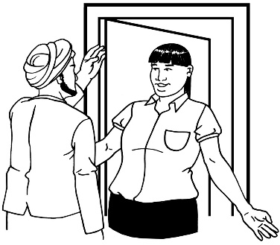
- welcome.

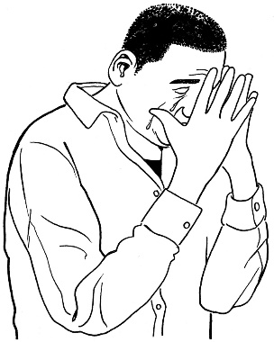
People said that in some of these places they do not feel:

- okay
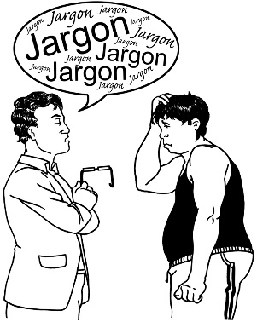
- understood.

Disabled people said they felt frustrated in places like this.

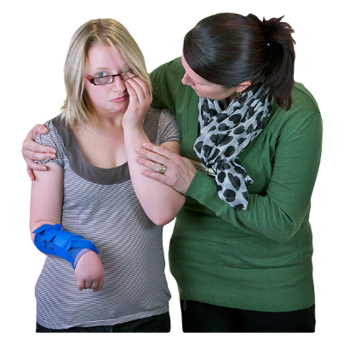
Frustrated means that someone is getting very angry or upset.

This can be because:
- they are not able to do something
- somebody they are talking to cannot understand them.

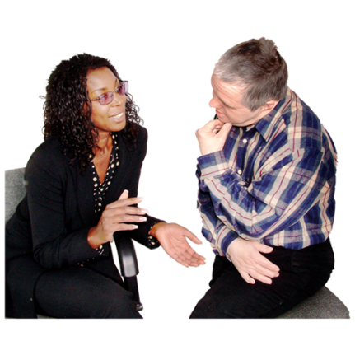
People also said that even in disability spaces they still had to explain to people personal things about themselves like their:

- disability
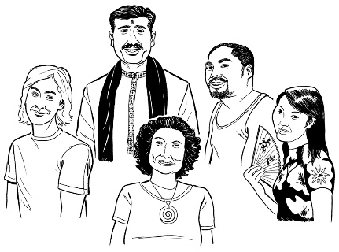
- culture

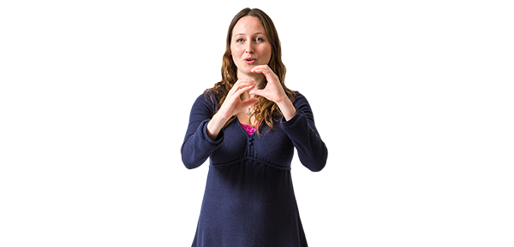
Culture is a word for the way a group of people live their lives.
For example this can mean the:
- language they speak
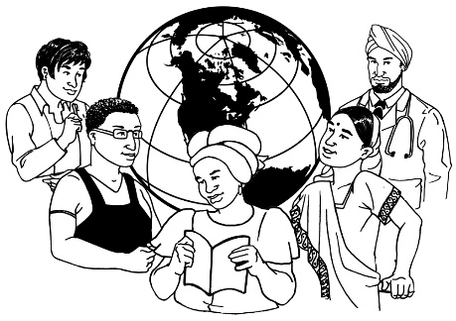
- way they might do things
- things they eat
- things they wear.

Another thing people said they sometimes felt they had to tell people about at these places was their gender.

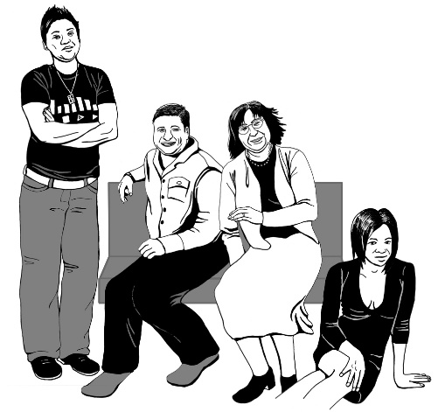
Gender is about how a person feels whether they are:

- male
- female
- a mix of male and female
- not male or female.

What did people say about
public spaces?

Public spaces are spaces where everyone is allowed to go.

A public space can be somewhere like a:
- park
- beach
- library.
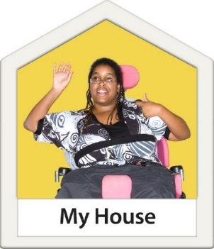

Your house is not a public space because it is where only you and your family live.
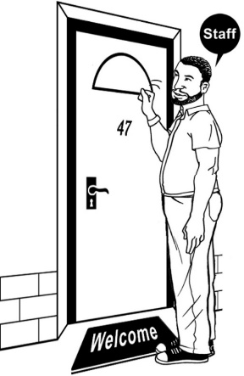

You only have to let people you want to into your house.
Some of the public places people talked about were:

- libraries
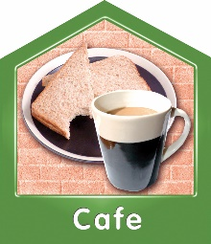
- cafes
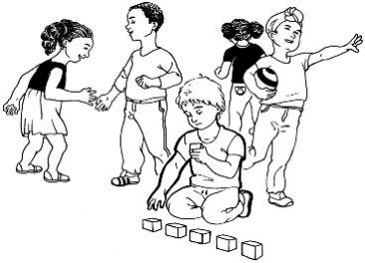
- playgrounds

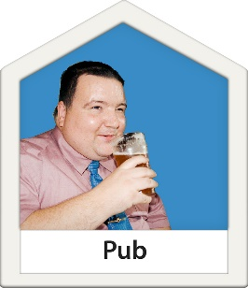
- hobby clubs

- pubs
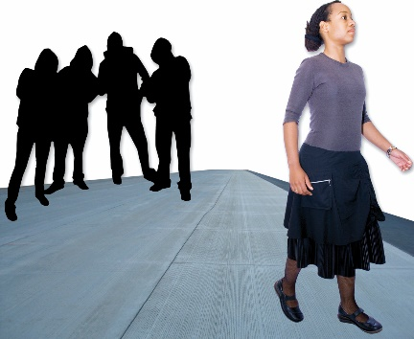
- on the street.

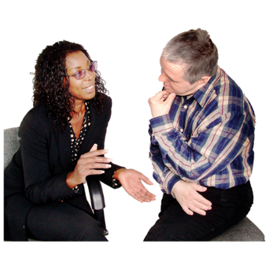
People talked about being in these places with different people like:

- friends
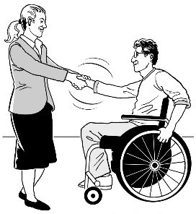
- people they had just met
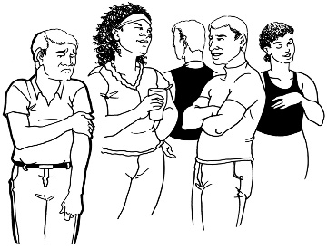
- strangers they did not know.

Not so good things about being in public places:

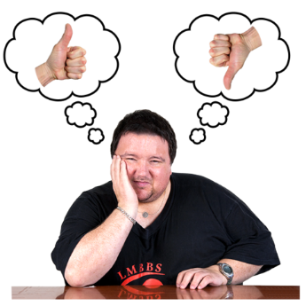
People said that sometimes people in public places think they know things about them when they do not.

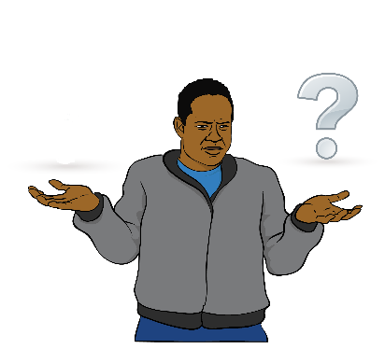

Sometimes strangers ask them questions they do not like.

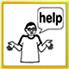
Sometimes people try to help disabled people when they do not:

- want help
- ask for help.

What did people say about school?
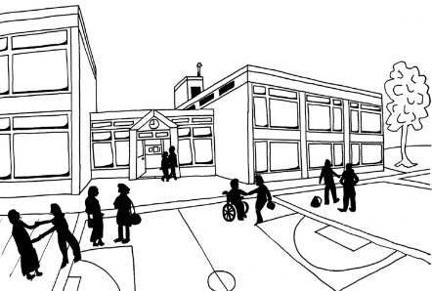

School was still an important place for lots of people the researchers talked to.

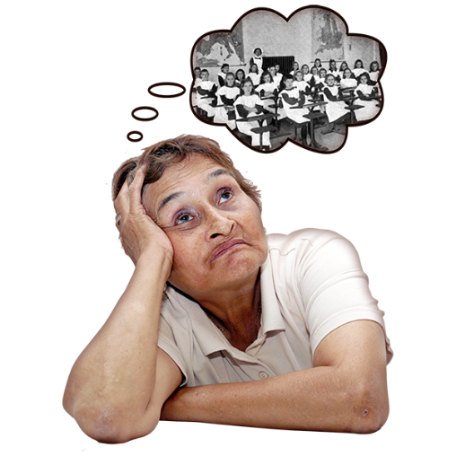
Disabled people talked about what school was like for them.

They remembered what school was like when they were young.

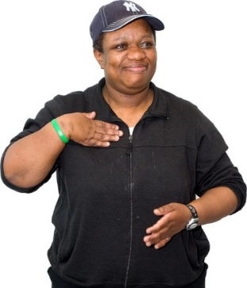

Even though they are adults now school is still a big part of who they are.

Good things about schools:

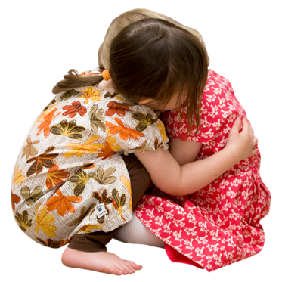

Parents said it was important for their children to have friends to feel like they belonged.

Not so good things about schools:

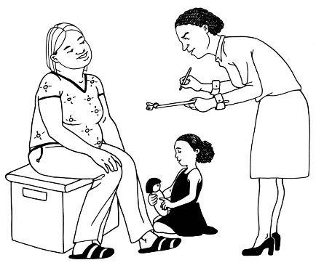
Parents said they sometimes do not feel welcome at their child’s school.

Parents said they sometimes feel like schools have more power than them.

Parents felt that teachers sometimes did not listen to them when they tried to say what their child needed at school.

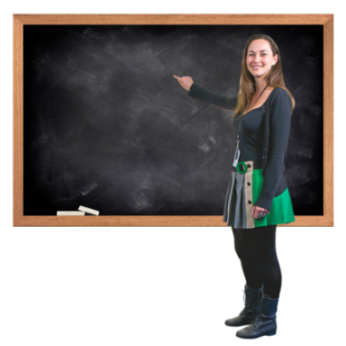
Parents felt teachers sometimes thought they knew more about what their child needed.

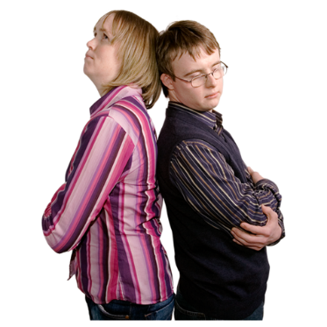
These things make it hard for parents to feel like they are part of their child’s life at school.

What did people say about work?

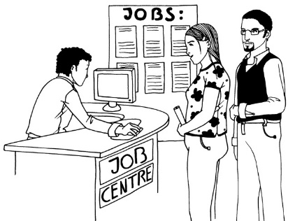
Some of the people we talked to:
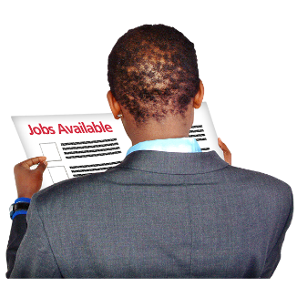
- had a job
- did not have a job.


Some people got paid to do their job.



Some people did work they were not paid for.

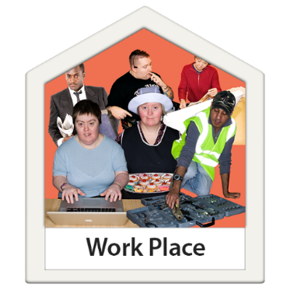

9 people did work that was for disabled people.

Not so good things about work:

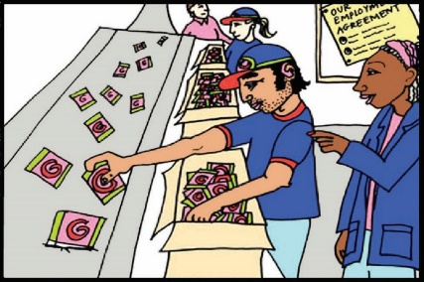
Disabled people said they sometimes felt like they were being watched very closely at work.

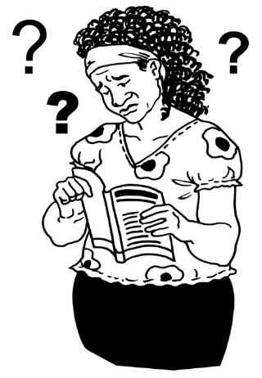
Disabled people sometimes
felt like work was hard because they had to work like they did not have a disability.

What did people say about
dating and relationships?

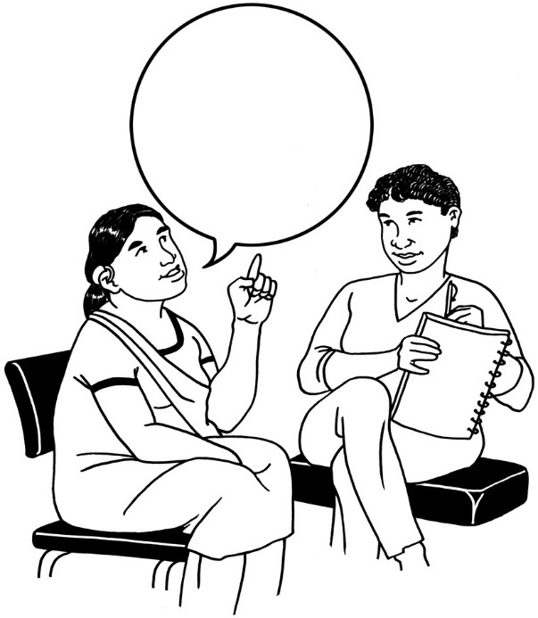
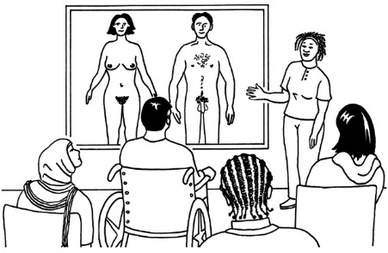
Disabled people do not get to say what they think about dating very often.

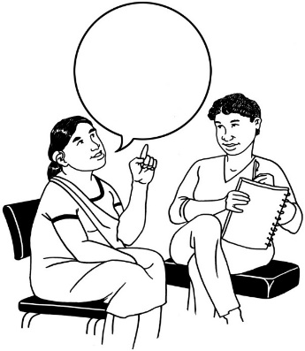
Disabled people had the chance to talk about dating in this research project.

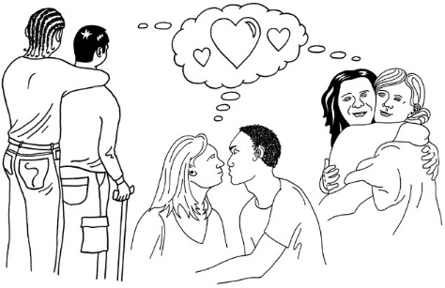
People talked about:

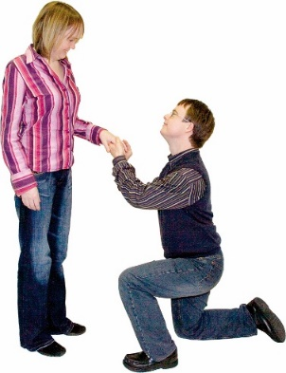
- who they were dating

- who they married

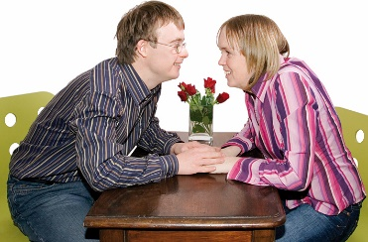
- who they were in love with

- where they went on dates
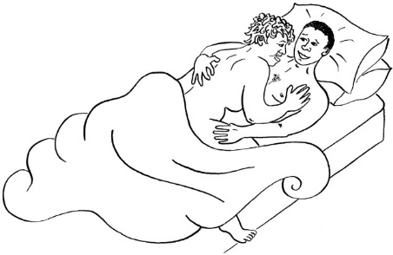

- having sex.

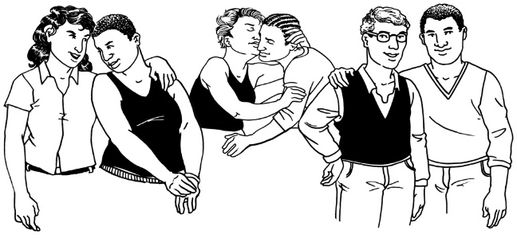
The people we talked to were in relationships with other people who were:

- the same gender as them

- a different gender from them.
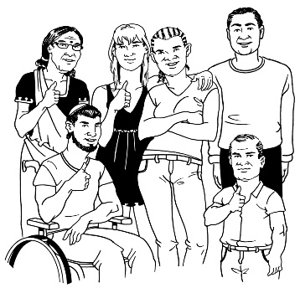
Disabled people wanted other people to know that not every disabled person is the same.
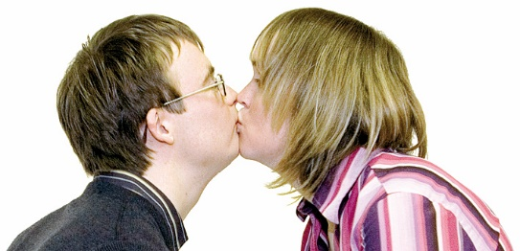

Some people were in relationships when we talked to them.

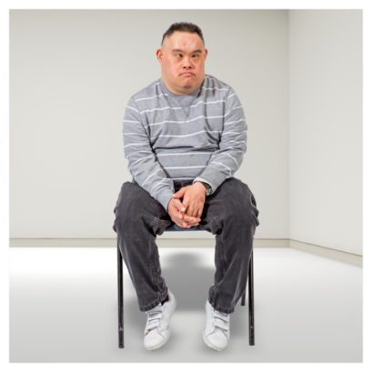
Some were not.

Not so good things about relationships:

For some people having relationships is harder than for others.

Sometimes people think that disabled people:

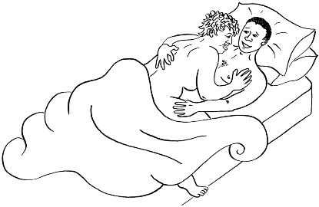
- do not want relationships

- cannot have sex.

We know that these things are not true.

Some people do not know how to
make sure disabled people feel comfortable and welcome on a date.

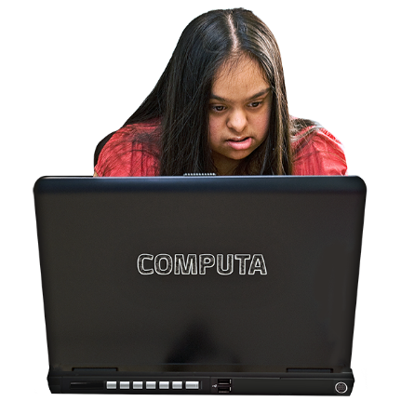
Online dating was also hard for some disabled people we talked to.

Why is this research important?

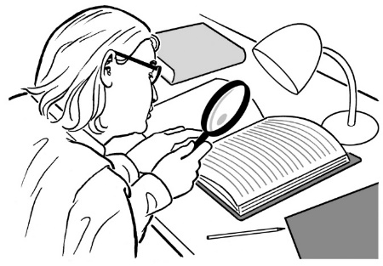
A lot of research is done about disabled people.

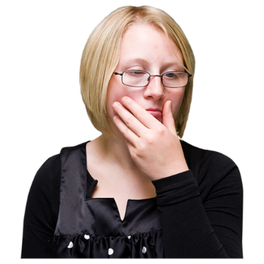
Most of the time disabled people do not have a say on:
- how the research is done
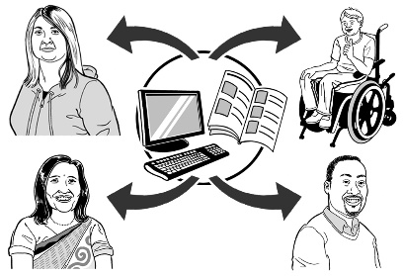
- what happens with the information the researcher finds out.

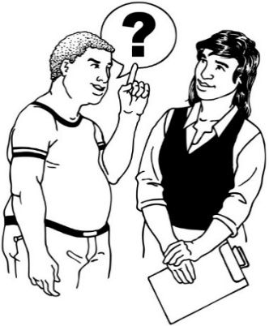
Disabled people are not usually the people who decide:

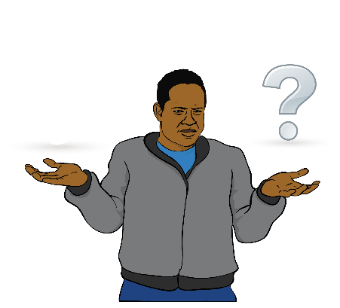
- what is important to know
more about

- what questions to ask.

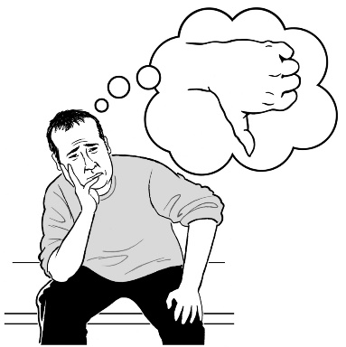

This is because some people do not think disabled people are experts about their own lives.

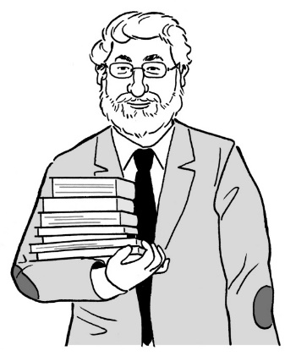
An expert is someone who knows a lot about something.

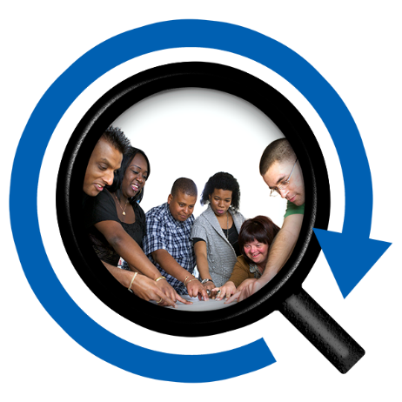
Our research was different because it was done by:
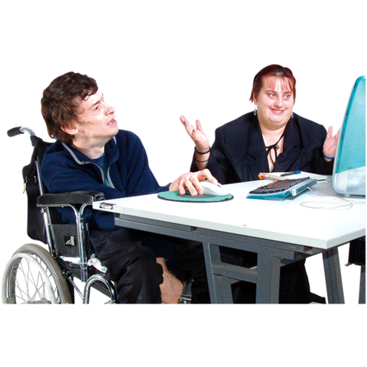
- a disabled person

- someone with a disabled person in their family.

Esther and Carey Ann worked together.

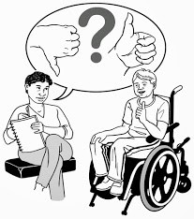
They:
- asked the questions
- made decisions together.

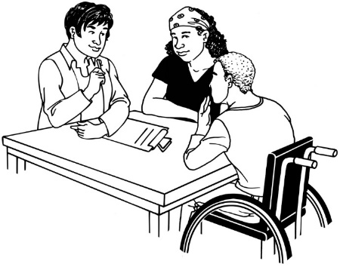
Their research is important because there is:

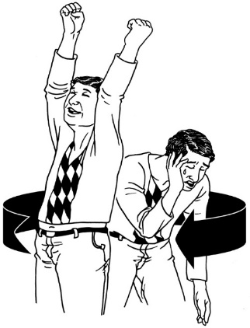
- lots of information about how many disabled people go to places like school or work

- not very much information about what disabled people or their families think and feel about these places.

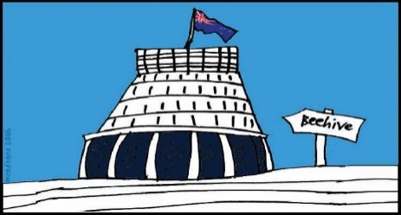
The Government uses information to make decisions about how to make lives for disabled New Zealanders better.

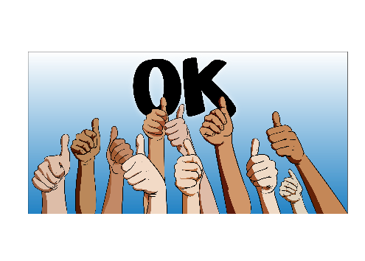
Having information like this could help the Government to make better decisions for disabled New Zealanders.

How can I find out more about this research project?

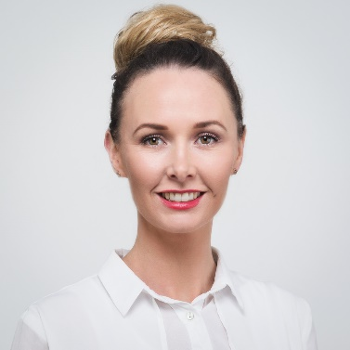
Contact Carey Ann if you want to find out more about our project.


This is her email address:

carey-ann.morrison@imaginebetter.co.nz

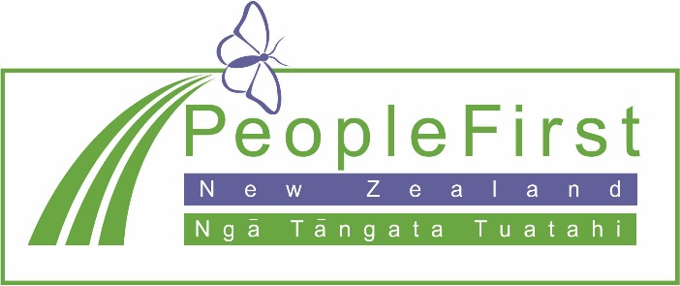

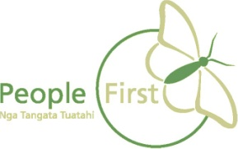
This information has been translated into Easy Read by the Make It Easy service of People First New Zealand Inc. Ngā Tāngata Tuatahi.

The ideas in this document are not the ideas of People First New Zealand Ngā Tāngata Tuatahi.


