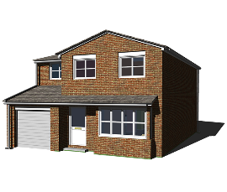 | Stay at Home  At the moment we are all asked to Stay at Home to protect ourselves and other people from the Covid 19 virus or Coronavirus.

Stay Safe
When you Stay at Home you should be safe at home.
You should have the food, medicines and clean clothes that you need.
You should be able to heat the rooms that you live and sleep in.

The people you live with and the people that come into your home should be kind. They should respect you and treat you well.

You should not feel afraid at home.
Nobody should hurt you, frighten you or treat you badly.
If someone hurts you or frightens you or treats you badly that is called abuse.

Ask for Help
If you need help or if you are worried or afraid talk to a family member, a friend or staff member that you trust.

You can ask for help.

Services that Can Help
There are services in your community that are there to help you.
People in these services will listen to you, talk to you and try to help you. They can help to stop abuse.

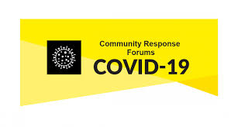 | Shopping and Medicine  Local volunteers can assist with shopping, getting medications or taking you to the doctor and many other supports.  Your local number to call is in this list. Look for your area and call the number if you need help. The volunteers are organised by your local county council community response forum.
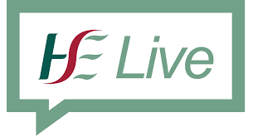 | Health Services  HSE Live can help you find a health service to support you.  The HSE Live national phone number is 1850 241850. The phone line is open from 8am to 8pm Monday to Friday and 10am to 5pm on Saturday and Sunday.  HSE Safeguarding Teams  The HSE has a social work service that you can contact if you have a concern about a vulnerable adult who may be at risk of abuse.  You can call the HSE’s National Safeguarding Office at  (061) 461 358

Physical Abuse
Physical abuse is when someone hurts your body. It can involve being pushed, shoved, kicked or slapped.

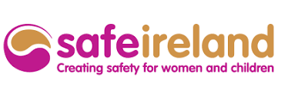   | Safe Ireland help to protect women and children from physical abuse.  Their free helpline number is  1800 341 900  Mens Aid Ireland is an organisation supporting men and their families experiencing abuse in their home. Their helpline number is  01- 544 3811.

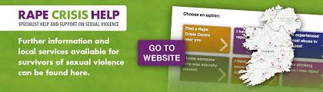 | Sexual Assault  Sexual assault is when someone touches your body or your private parts when you do not want them to.  If you have been sexually assaulted or attacked you can contact your local Rape Crisis Centre for help.  You can call Rape Crisis Help at 1800 77 88 88 - 24 hours a day every day of the year.  There is more information on the Rape Crisis Help website at www.rapecrisishelp.ie

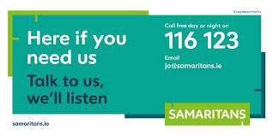   | Someone to Talk To  If you are worried, if you are struggling to cope or if you feel you need some extra support you can phone an organisation called the Samaritans.  You can call the Samaritans free any time, from any phone, on  116 123.  A volunteer will answer your call and will listen to you.  If you are feeling alone or afraid or if you are in distress or self-harming you can talk to a therapist at any time, day or night, at Pieta House.  Call free 1800 247 247 or text Help to 51444.

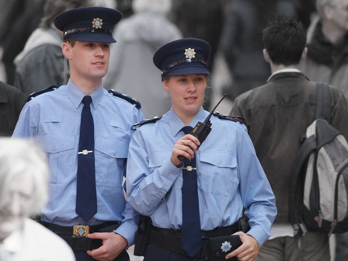 | Police Service –  An Garda Siochana  If you are in immediate danger call 999.  The police will call to your house to make sure you are safe.  If you are not in immediate danger and you need advice and help, you can visit your local Garda Station. You can ask to speak with the Garda in private.  In an emergency always call 999.

