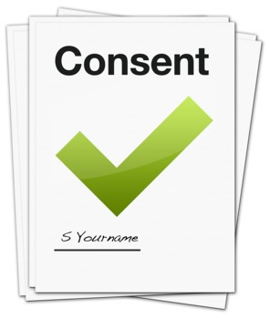
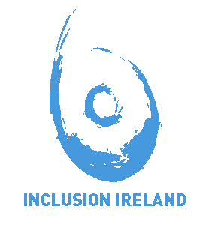
Consent Form for
Pictures and Videos for the Inclusion Ireland Website
   | You recently sent us a photo to show us how you were #happyathome.
 | We would like to use this photo on the Inclusion Ireland website.
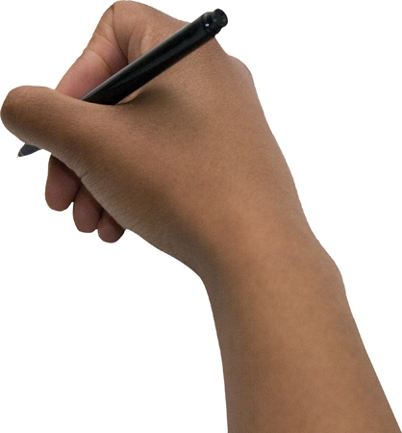         | This means that everyone who visits our website will see your photo. It will not just be people from Ireland but people from around the world.  It is important that you understand this information before you decide. Please tick yes or no below and sign the form. Thank you.  Yes, I agree that my picture can be used like this.  No, I don’t agree my picture can be used like this.  Signed: ___________________________  Date: _____________________________  Name: ____________________________

