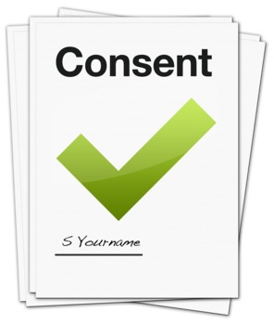

Safeguarding Consultation Consent Form

Please read this form and sign the consent form if you wish to take part in a discussion group.


Please tick each box if you agree:
 | I have read the information leaflet on the Safeguarding Consultation.
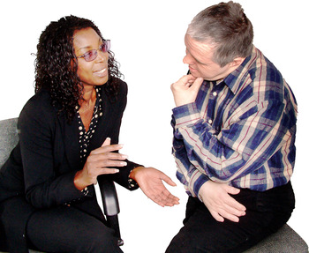 | My questions have been answered.
 | I understand the information I give in the discussion group will be kept safe and private.
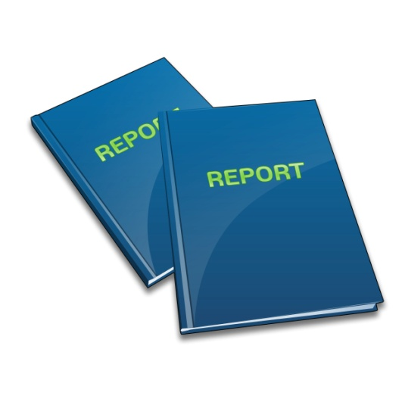 | I understand Information I give will be used in a report written for the National Safeguarding Office.
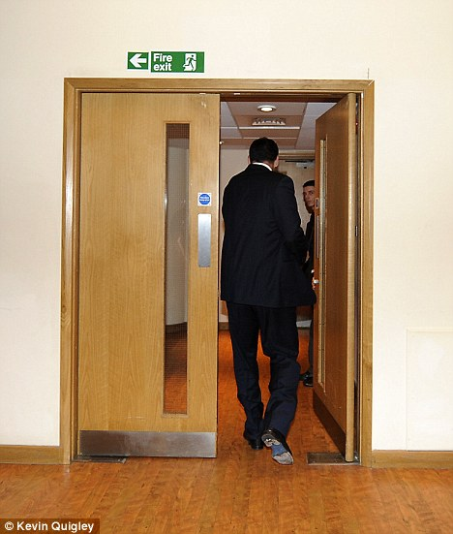 | I understand I can change my mind and leave the discussion group at any time.


Please sign your name and give your contact details if you want to take part in the discussion group.
_______________________________
Address:
Email:
Phone:

